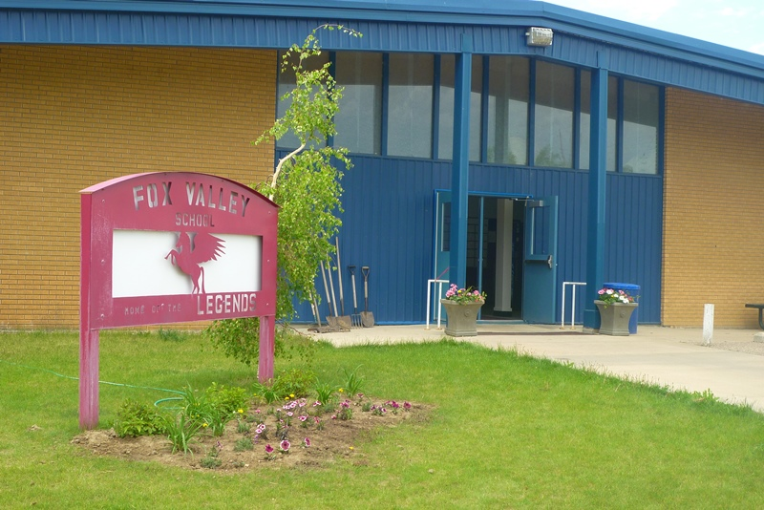
Fox Valley School Newsletter
March 1st, 2019

Congratulations to the Jr. Girls Curling Team on winning
SWAC!!!!

FOX VALLEY SCHOOL
COMMUNITY APPRECIATION NIGHT
(Fox Valley, Burstall, Golden Prairie and Richmound Communities)
THURSDAY, APRIL 4TH

A free supper will be provided for all community members, parents, friends, family, students, staff, etc… The menu is yet to be determined but will, in large part, be prepared by Mr. Glass’ Foods 10 class. This is open to everyone – come one, come all!

Following supper, the Leader RCMP will be here from 6:00 – 6:30 to answer questions regarding the new laws around Impaired Driving and the legalization of marijuana. This informal session is open to all – parents, students, community members, etc…

The SRC will be offering FREE Babysitting!!!!

The AMAZING RACE – LEGEND STYLE – will start at 6:30 and is looking like it is going to be a lot of fun! There are two categories you can register in: Family or Open

General Rules and Information
- Teams can have between 3 and 6 team members
- Can enter as a team or an individual. Individuals will be placed on a team
- Prizes will be awarded to the following groups:
  - Team spirit award
  - Best team costume
  - Winner, Family Amazing Race
  - Winner, Open Amazing Race
  - Had the most fun but not necessarily did the best Award…

Family Amazing Race
- This category is meant for parents and their children to enter together as a team.
- Questions and activities in this race will be geared towards elementary classrooms and students.
Open Amazing Race
- This category is more competitive with questions and activities based on middle and high school courses.
- These teams can be family teams with older kids or students can enter their own team, community members can get together and enter, etc…
Teams can be made up of a variety of people and combinations. Examples could include:

- Grad 2010
- The Blonde Bombers
- Sr. Girls Volleyball, 2018
- Hockey Rules
- The “We love Liver Group”
- Provincial Champs
- Badminton Birdettes
- Legend Imports
- Richmound Lions Club
- Fox Valley Village Office
- Fox Valley Staff 2019
- I used to have hair but now I’m bald
- Etc…etc…etc… The sky’s the limit on your imagination!!

The Fox Valley School Staff would like to thank the SCC for the wonderful treats they received during Teacher/Staff Appreciation Week!!

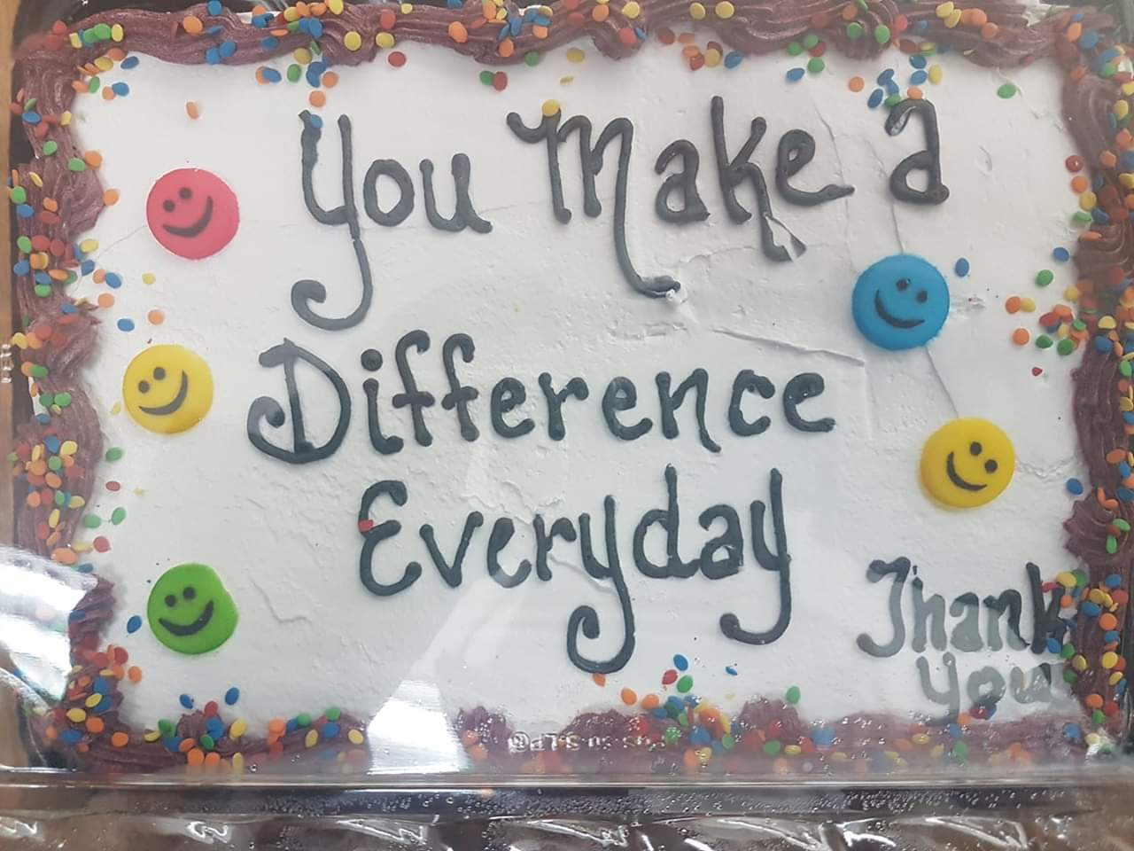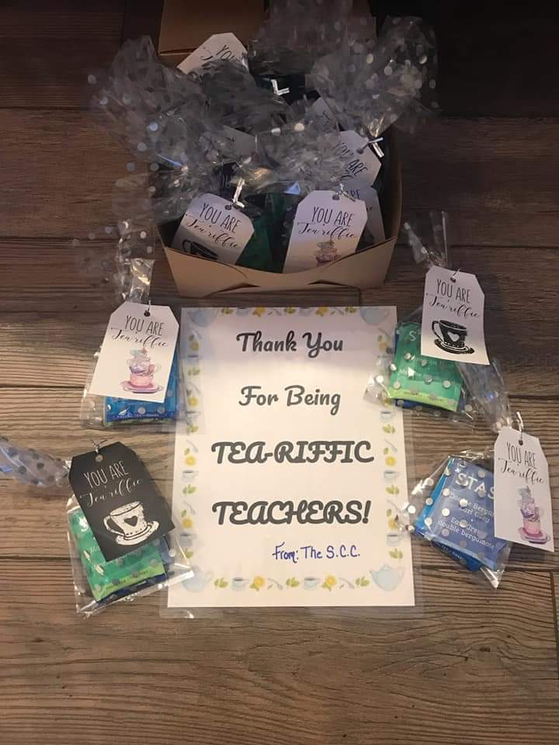

Parent/Teacher Conferences – will be held on March 27th & 28th from 4 p.m. – 6:30 p.m. **Please Note the times have changed!!! Letters regarding conference times for Kindergarten to grade 5 and for grades 9 to 12 (GRAD planning) will be mailed this week. Grades 6 – 8 will be a first come first serve conference. Any Questions please call Mrs. Wilde.

JR Matthews Presentation will be held on March 28th. He will focus on self-esteem development, how thoughts become things and how, what we think about most of the time shapes the world we see around us. When we can believe more firmly in ourselves we can accomplish so much more. This presentation will be for all students and parents are welcome to attend. When we have confirmed times, it will be posted on the school website!!
SRC
The SRC will be hosting a St. Patrick’s Day Dance for the Kindergarten to Grade 5 students! Date will be posted this week!!

What’s Happening In the Classroom

The K-1 Class will be reading Dr. Suess books this month. We will be listening for rhyming words and creating our own rhyming pairs.
On Saint Patrick's Day we will read Green Eggs and Ham. Then we will all try to eat green eggs in ham just like Sam-I-Am.
We are also looking forward to building a leprechaun trap to catch a Leprechaun on Saint Patrick's Day! Don't forget to Wear Green!! – Mrs. Hudec
Grade 2/3
The grade 2/3 students will be doing square dancing for their dance unit for the art/P.E. curriculum. This month will be a time to help your child celebrate their learning and growth at S.L.C's at the end of the month. – Mrs. Sunde

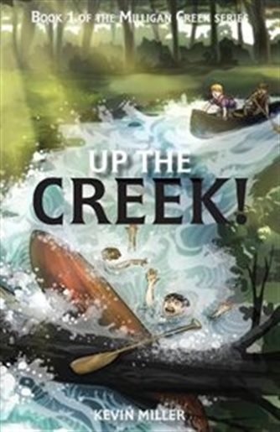
Grade 4/5 class
The Grade 4/5 class is looking forward to spring coming and warmer weather. We finished reading the novel A Dog's Life which they all enjoyed and hated to see come to an end. We are now reading Up The Creek by Kevin Millar who visited in February. – Mrs. Hoffart

The grade 4/5 class has been learning about Forces and Simple Machines in Science and we have been learning about Canada as a multicultural nation in Social Studies. Fitness February has come to an end for the grade 6-9 students and I am sure they are going to miss our daily workouts! Gymnastics was a success with grade 2-5 and the routines the students created were fantastic. The grade 2-5 classes are beginning our Dance unit in March. Grade 6-9 are starting our Badminton unit. – Miss Peers

The grade 6 and 7's are finishing up their units on fractions and will be writing an exam this week.
In math 8 we have just began our unit on proportions and unit rates. The grade 9's are finishing up their unit on polynomials and will be writing an exam this week. – Mr. Lehmann

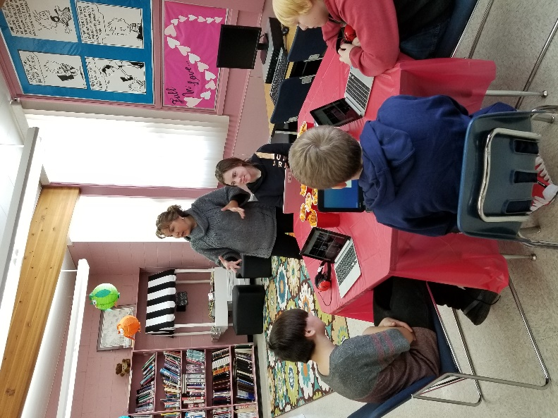
The students in ELA 6 and ELA 7 were treated to an awesome experience at the Poetry Cafe in the library on February 25th. Three main courses of poetry were served which included viewing poetry recitation, matching poems to authors and writing poetry. The students also enjoyed snacks and drinks as they indulged in literature. A huge thank-you to our librarian, Charissa Bosch, for facilitating this gala event. – Mrs. Kosolofski

And thank you to the SCC for sponsoring the Poetry Café!!

Our little Rainbow Trout are doing very well and we are several days into feeding them. – Mr. Glass

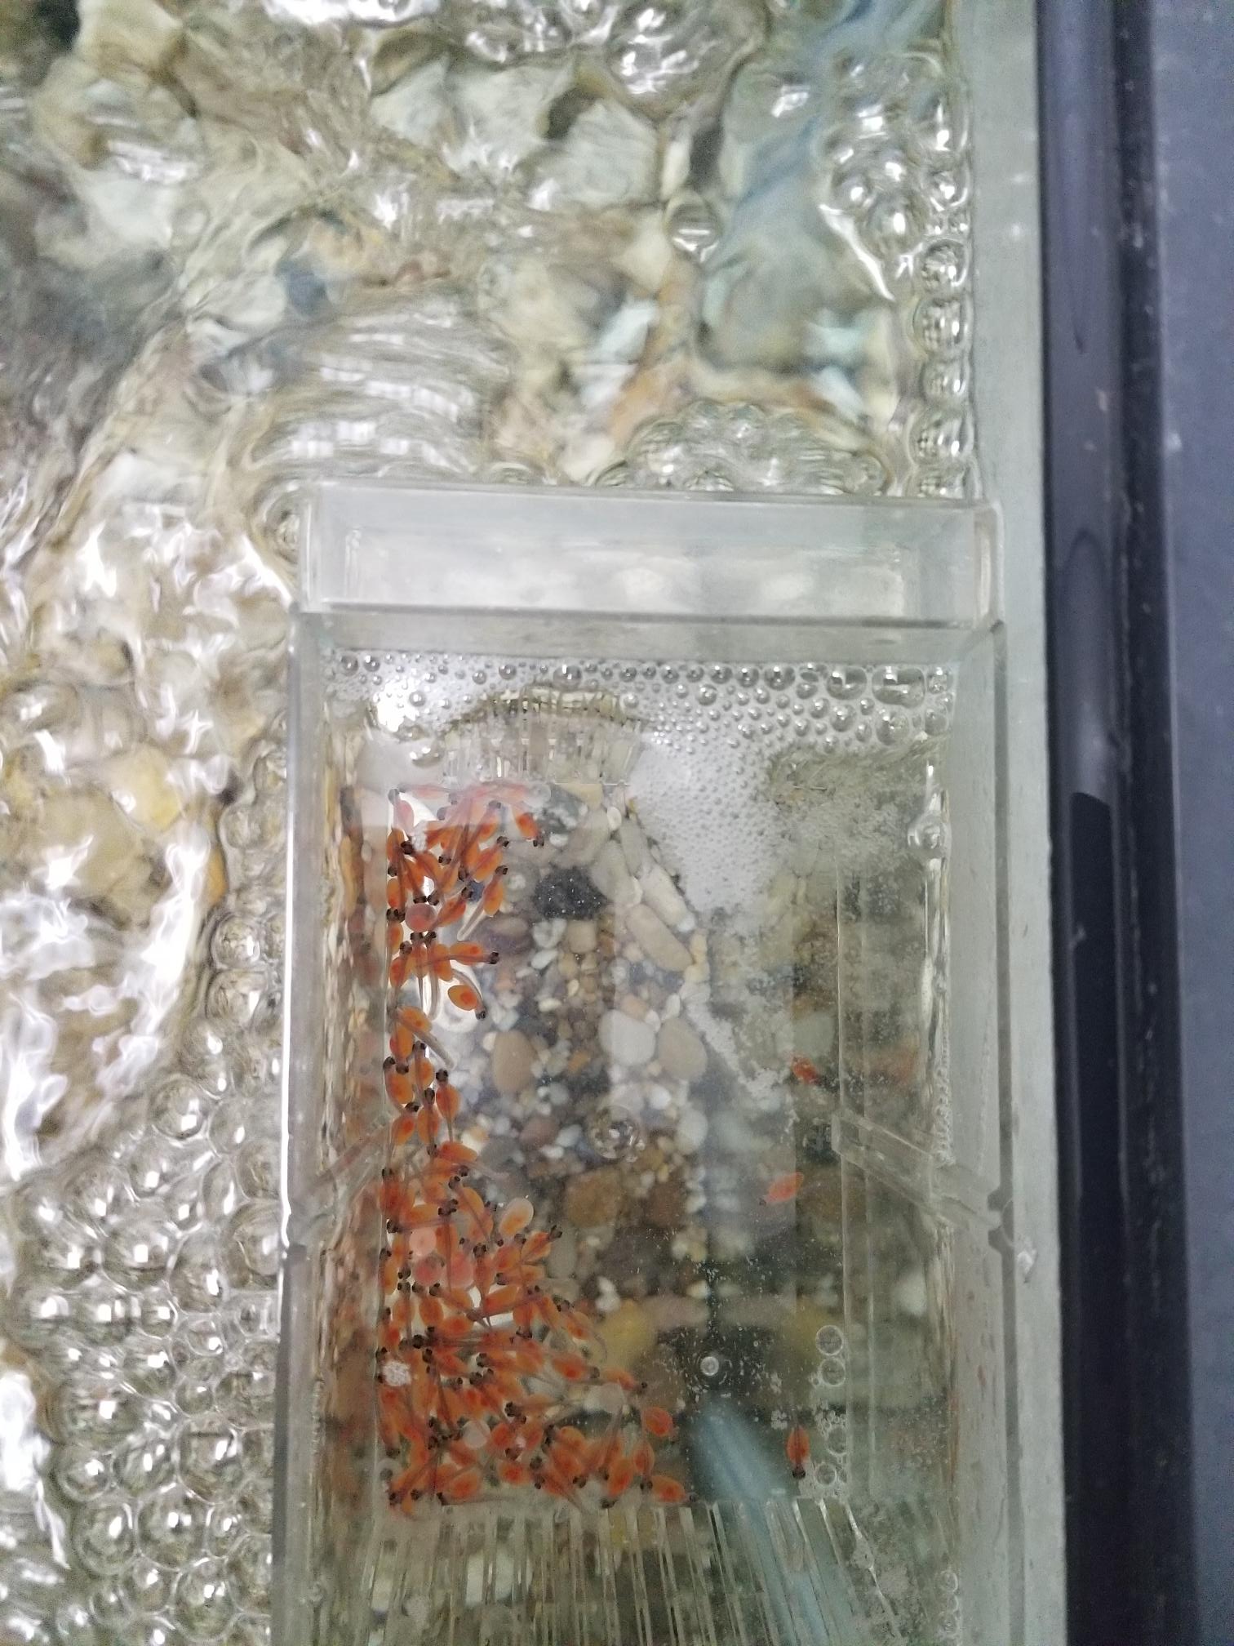

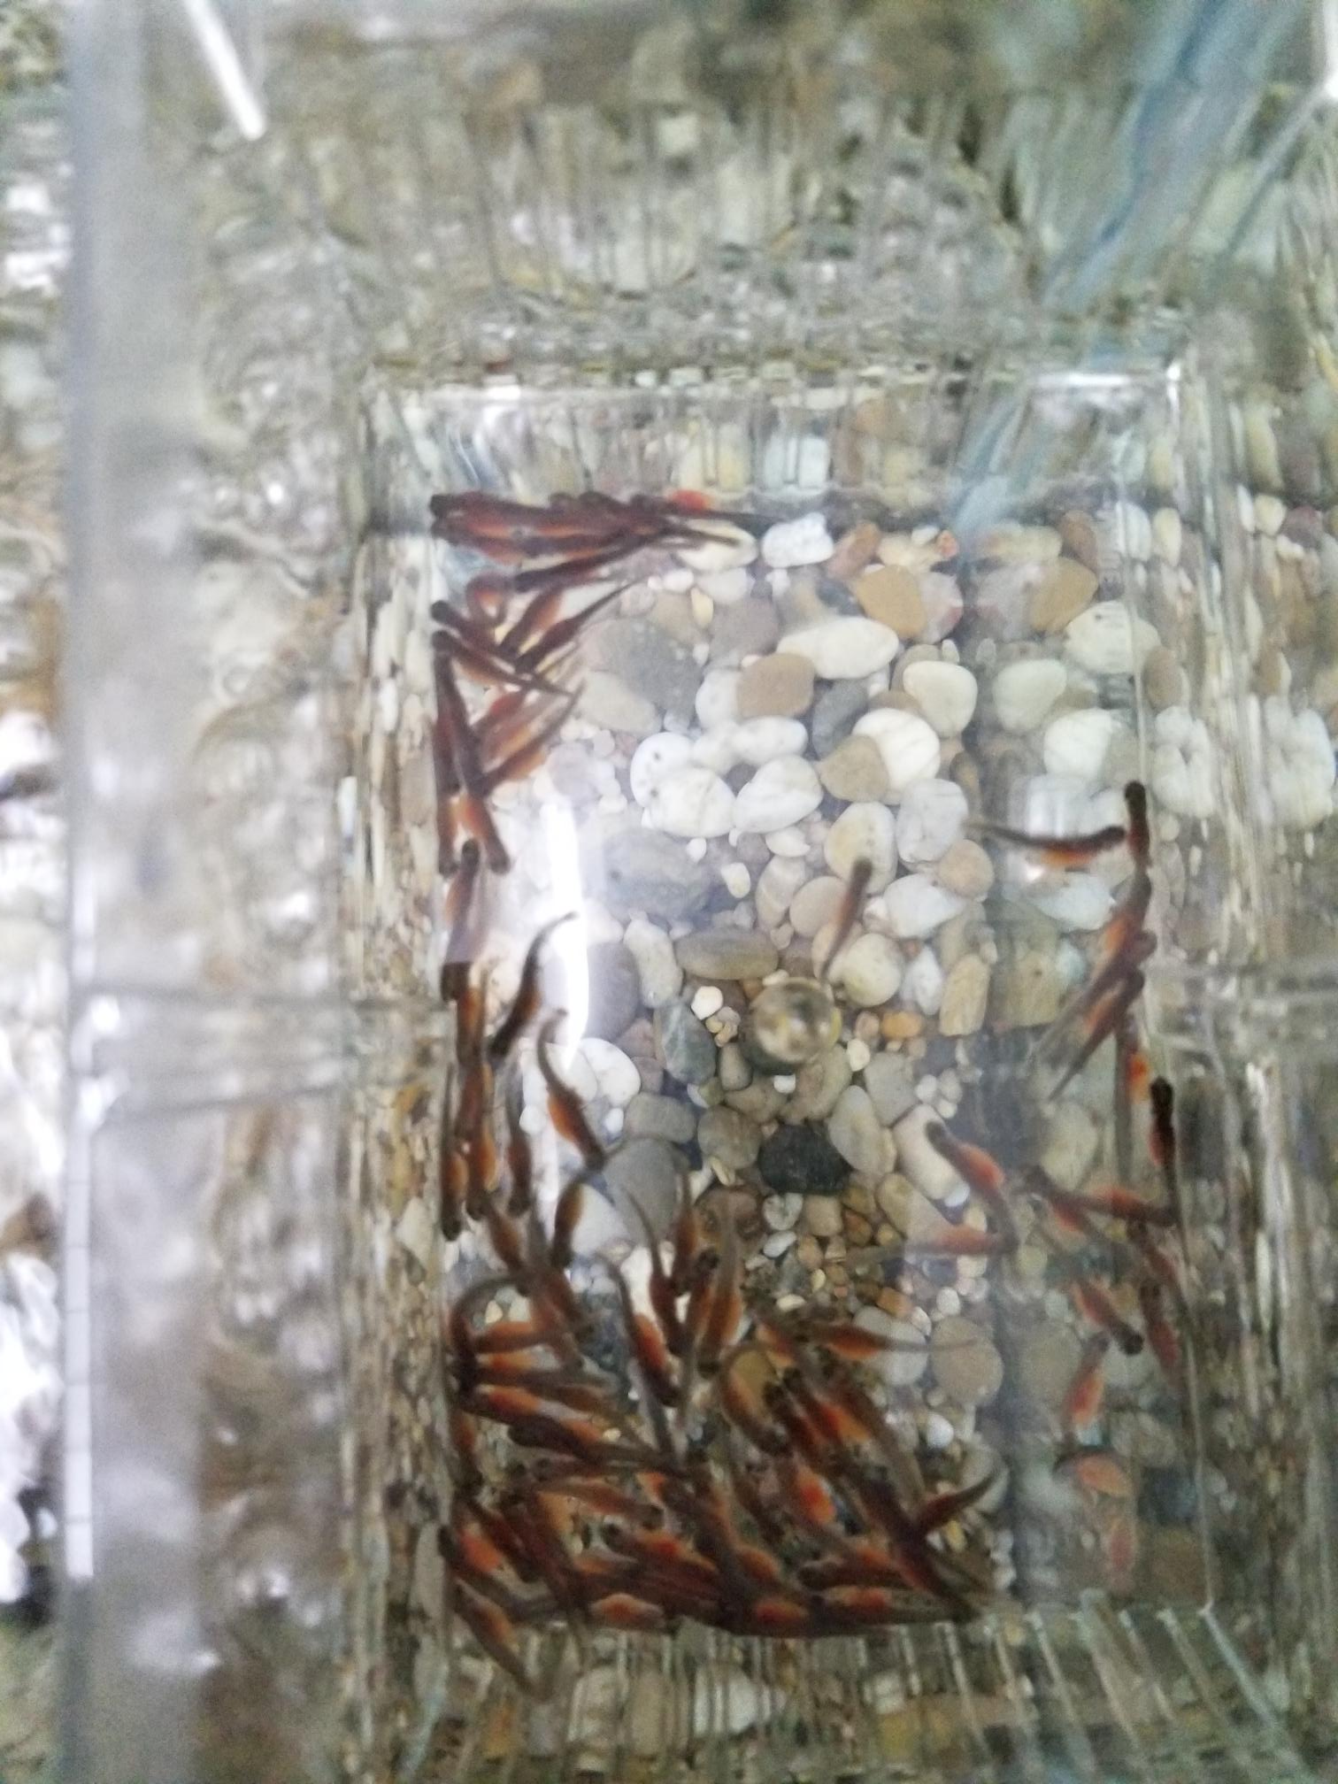

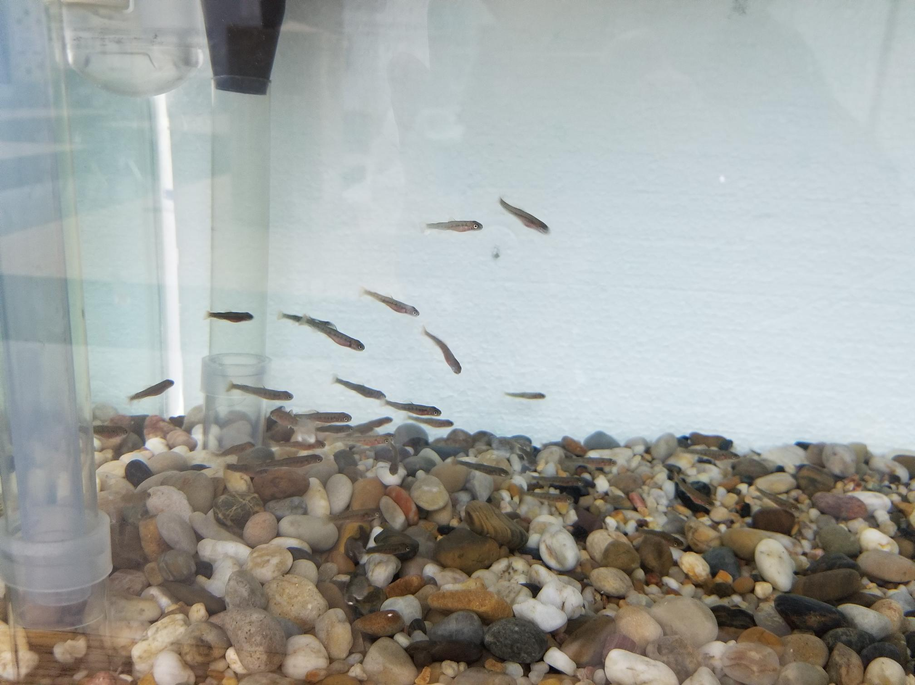

The Physical Science 20 class studied the properties of waves by using "Slinkys". – Mr. Schmitz

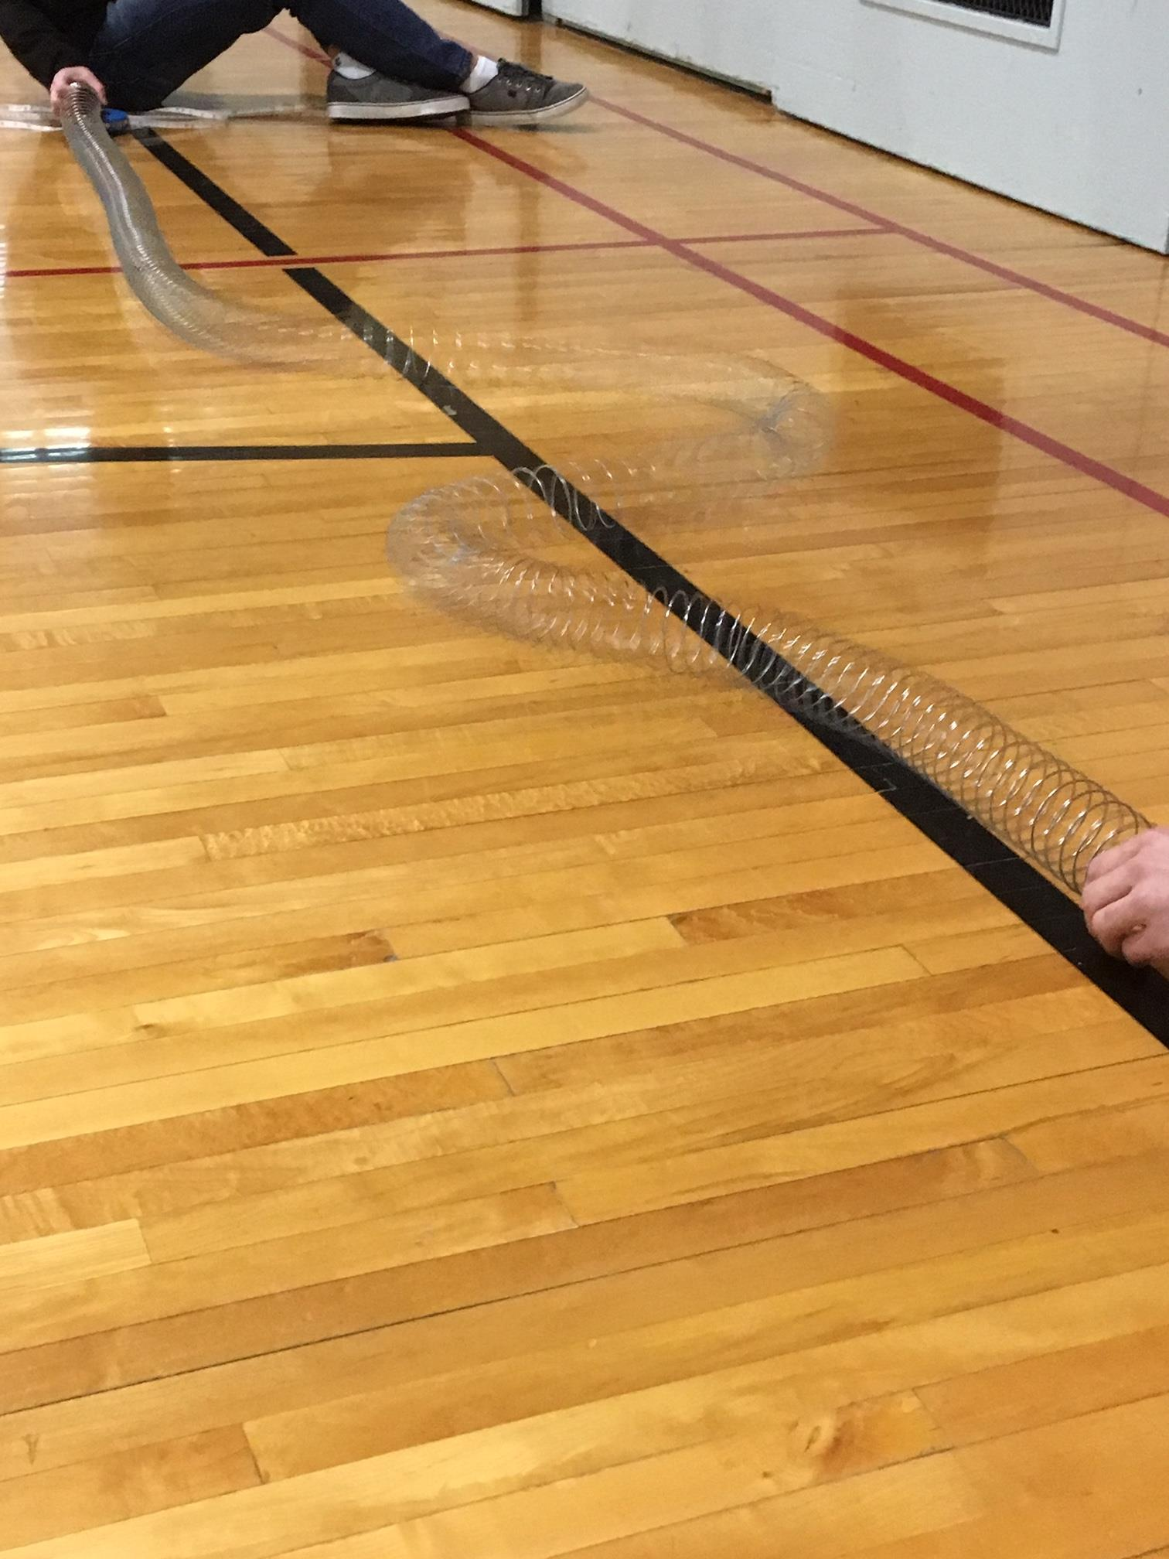
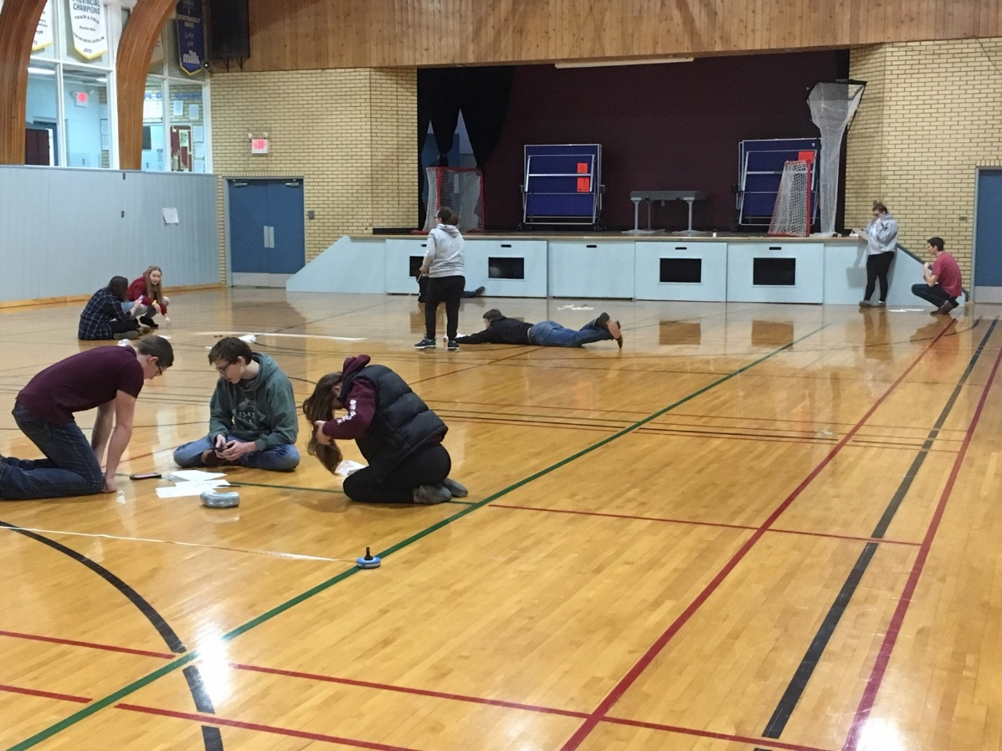
SCC March PoeTree
Thank you to the Grade 2/3 class for the wonderful poetry for March!! The randomly picked winner of the Grade 4/5 PoeTree for February was Nevaya Hellman!!!
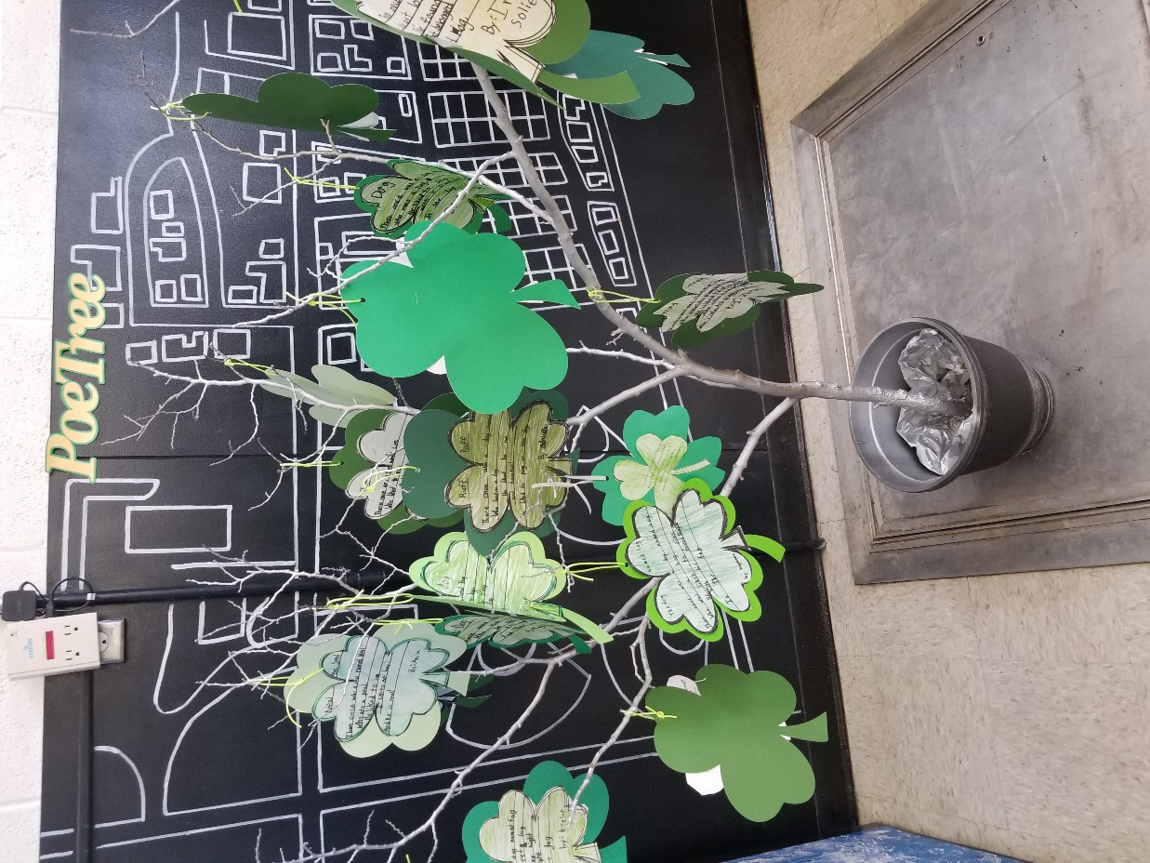

March At A Glance
March 5 & 7 – Jr. Badminton Practice
March 8 – Noon Lunch – Pizza Buns $3 for 1 or 2 for $5, includes a juice box
March 9 – Jr. Badminton Tournament at Burstall
March 12 & 14 – Jr. Badminton Practice
March 15 – Subway
March 15 – Dress in GREEN for St. Patrick’s Day!!!
March 19 – Jr. Badminton Practice
March 19 – SCC Meeting @ 7 p.m.
March 20 – GRAD & Kindergarten GRAD Cap & Gown Pictures
March 21 – NO SCHOOL
March 22 – NO SCHOOL
March 23 – Jr. Badminton Tournament @ Leader
March 26 & 27 – Parent/Teacher Conferences 4 p.m. to 6:30 p.m.
March 28 – JR Matthew Presentation
March 28 – Jr. Badminton Practice
March 29 – NO SCHOOL
March 30 – Jr. Badminton Tournament @ Maple Creek

